ERD Description
Entities and Attributes:
- student_numbers:
  - Attributes:
    - id (INT, Primary Key, Auto-Increment)
    - student_number (VARCHAR(20), Unique, Not Null)
    - created_at (TIMESTAMP, Default: CURRENT_TIMESTAMP)
  - Purpose: Stores pre-populated student numbers for residence residents.
- students:
  - Attributes:
    - id (INT, Primary Key, Auto-Increment)
    - student_number (VARCHAR(20), Unique, Not Null, Foreign Key to student_numbers.student_number)
    - name (VARCHAR(50), Not Null)
    - surname (VARCHAR(50), Not Null)
    - email (VARCHAR(100), Unique, Not Null)
    - phone (VARCHAR(20), Null)
    - password (VARCHAR(255), Not Null, Plain Text)
    - room_number (VARCHAR(10), Null)
    - notification_opt_in (TINYINT(1), Default: 1)
    - created_at (TIMESTAMP, Default: CURRENT_TIMESTAMP)
  - Purpose: Stores student profiles created during registration.
- admins:
  - Attributes:
    - id (INT, Primary Key, Auto-Increment)
    - username (VARCHAR(50), Unique, Not Null)
    - name (VARCHAR(50), Not Null)
    - surname (VARCHAR(50), Not Null)
    - email (VARCHAR(100), Unique, Not Null)
    - password (VARCHAR(255), Not Null, Plain Text)
    - created_at (TIMESTAMP, Default: CURRENT_TIMESTAMP)
  - Purpose: Stores admin accounts for residence management.
- categories:
  - Attributes:
    - id (INT, Primary Key, Auto-Increment)
    - name (VARCHAR(50), Not Null)
  - Purpose: Defines communique types (e.g., Maintenance, Alerts).
- communiques:
  - Attributes:
    - id (INT, Primary Key, Auto-Increment)
    - admin_id (INT, Foreign Key to admins.id)
    - category_id (INT, Foreign Key to categories.id)
    - title (VARCHAR(100), Not Null)
    - description (TEXT, Not Null)
    - urgency (ENUM('Normal', 'Urgent'), Default: Normal)
    - attachment (VARCHAR(255), Null)
    - pinned (TINYINT(1), Default: 0)
    - views (INT, Default: 0)
    - created_at (TIMESTAMP, Default: CURRENT_TIMESTAMP)
  - Purpose: Stores communiques posted by admins.
- comments (Optional, pending confirmation):
  - Attributes:
    - id (INT, Primary Key, Auto-Increment)
    - communique_id (INT, Foreign Key to communiques.id)
    - student_id (INT, Foreign Key to students.id)
    - comment (TEXT, Not Null)
    - approved (TINYINT(1), Default: 0)
    - created_at (TIMESTAMP, Default: CURRENT_TIMESTAMP)
  - Purpose: Stores student comments on communiques (moderated).
- suggestions (Optional, pending confirmation):
  - Attributes:
    - id (INT, Primary Key, Auto-Increment)
    - student_id (INT, Foreign Key to students.id, Null for anonymous)
    - suggestion (TEXT, Not Null)
    - anonymous (TINYINT(1), Default: 1)
    - created_at (TIMESTAMP, Default: CURRENT_TIMESTAMP)
  - Purpose: Stores student suggestions (anonymous or named).
Relationships:
- student_numbers → students:
  - One-to-One: Each students.student_number must match exactly one student_numbers.student_number (enforced by foreign key).
  - Description: A student can only register if their student number exists in student_numbers, ensuring only valid residents create profiles.
- admins → communiques:
  - One-to-Many: One admin (admins.id) can post many communiques (communiques.admin_id).
  - Description: Admins create communiques, and the admin_id links to the poster’s details (e.g., name, surname).
- categories → communiques:
  - One-to-Many: One category (categories.id) can be associated with many communiques (communiques.category_id).
  - Description: Communiques are categorized (e.g., Maintenance, Alerts) for filtering.
- communiques → comments:
  - One-to-Many: One communique (communiques.id) can have many comments (comments.communique_id).
  - Description: Students can comment on communiques (if enabled), with admin moderation.
- students → comments:
  - One-to-Many: One student (students.id) can post many comments (comments.student_id).
  - Description: Links comments to the student who posted them.
- students → suggestions:
  - One-to-Many: One student (students.id) can submit many suggestions (suggestions.student_id), with student_id nullable for anonymity.
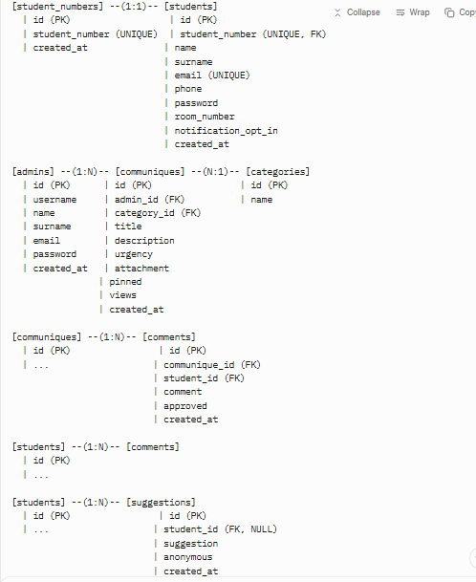
  - Description: Students can submit suggestions, optionally anonymously
How to Create the ERD:
- Use a tool like MySQL Workbench:
  - Import the SQL schema (provided above).
  - Go to Database > Reverse Engineer to auto-generate the ERD.
  - Adjust layout to show relationships clearly.
- Use Lucidchart or Draw.io:
  - Create rectangles for each table (e.g., student_numbers, students).
  - List attributes with keys (PK, FK, UNIQUE).
  - Draw lines for relationships (e.g., 1:1 between student_numbers and students, 1:N from admins to communiques).
  - Label relationships (e.g., “verifies” for student_numbers → students).
- Save as a PDF or image to share with the res manager or include in your project documentation.
Notes:
- The ERD assumes comments and suggestions are included. If you decide to exclude them, remove these tables from the diagram.
- Foreign keys ensure data integrity (e.g., students.student_number must exist in student_numbers).
- The 1:1 relationship between student_numbers and students is unique, as student_numbers acts as a pre-registration gatekeeper.

